Diploma in Pharmacy, First year Biochemistry TPP Abstract.

**Adarsh Shikshan Sanstha’s College of Pharmacy, Beed.**

**Post Box No.38 Nagar Road Beed.-431122**

**02442-203879 ;9371260002**

**02442-203879**

Surendra Kute

**2014-15**

**Vitamins**

**Vitamins**

* Definition:
* **Vitamins are organic compounds which are needed in small quantities to sustain life. We get vitamins from food, because the human body either does not produce enough of them, or none at all**
* Why Called Vitamins
* An organic compound contains carbon. When an organism (living thing) cannot produce enough of an organic chemical compound that it needs in tiny amounts, and has to get it from food, it is called a vitamin.
* Sometimes the compound is a vitamin for a human but not for some other animals. For example, vitamin C (ascorbic acid) is a vitamin for humans but not for dogs, because dogs can produce (synthesize) enough for their own needs, while humans cannot.
* What are Vitamins
* **What are vitamins?**
* A vitamin is one of a group of organic substances, present in minute amounts in natural foodstuffs, that are essential to normal metabolism; insufficient amounts in the diet may cause deficiency diseases.
* Put simply, a vitamin is both:
* An organic compound (contains carbon).
* An essential nutrient the body cannot produce enough of on its own, so it has to get it (tiny amounts) from food.
* There are currently 15 recognized vitamins.
* Classification of Vitamins:
* **Fat soluble and water soluble vitamins**
* There are *fat-soluble* and *water-soluble* vitamins.
* **Fat-soluble vitamins** are stored in the fat tissues of our bodies, as well as the liver. Fat-soluble vitamins are easier to store than water-soluble ones, and can stay in the body as reserves for days, some of them for months.
* Fat-soluble vitamins are absorbed through the intestinal tract with the help of fats (lipids).
* **Water-soluble vitamins** do not get stored in the body for long - they soon get expelled through urine.
* Water-soluble vitamins need to be replaced more often than fat-soluble ones.
* Vitamins A, D, E and K are fat-soluble.
* Vitamins C and all the B vitamins are water-soluble.
* **Vitamin A**
* Fat Soluble vitamin present in foods of animal origin.
* It’s provitamin present in plant ( Carotene)
* Vitamin A responsible for to cure night blindness.
* Pro-vitamin A

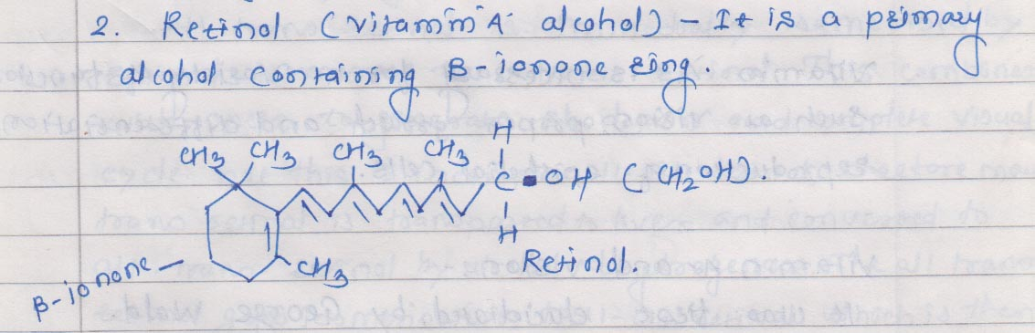

* Retinal Aldehyde form obtained by oxidation of Retinol

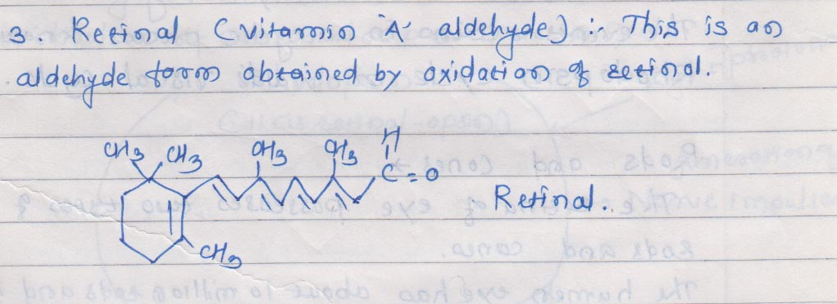

* Retinoic Acid

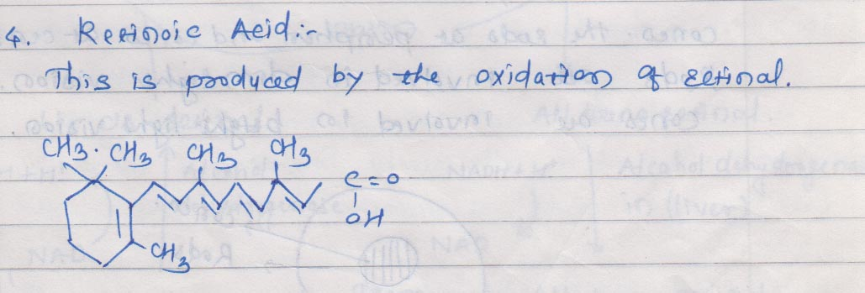

* Beta Carotene Found in Plant

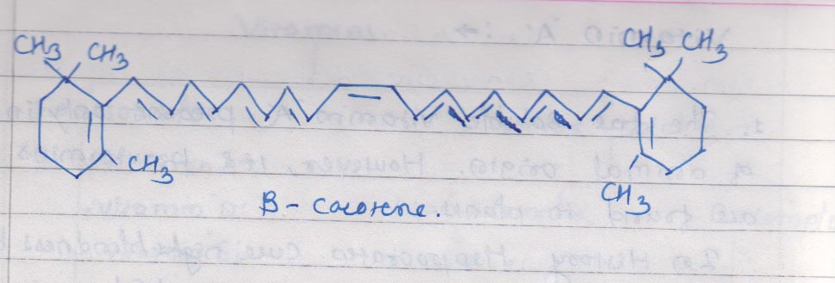

* Biochemical Functions of Vita. A
* Vision.
* Proper Growth
* Reproduction of epithelial cells.
* Vitamin A and Vision:
* Rhodopsin Cycle:
* Rods: 10 millions Dim Light .
* Cone: 5 Millions Bright Light.
* Rods And Cones:

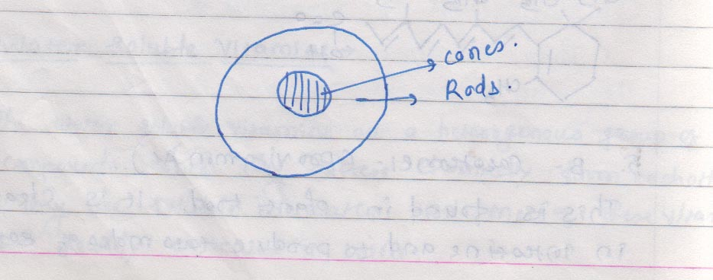

* Rhodopsin Cycle:

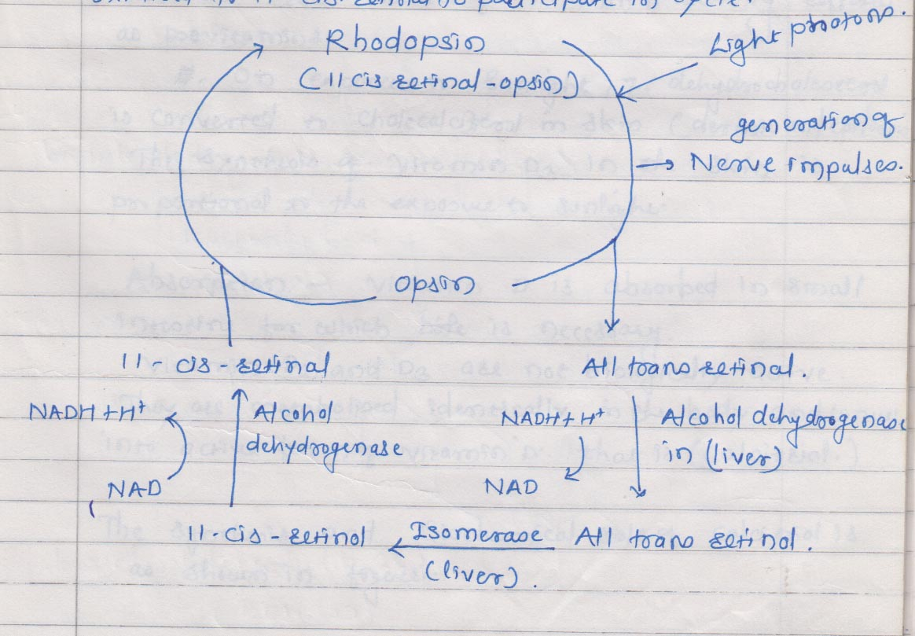

* Deficiency of Vitamin A
* Mucous Secretion Depressed.
* Decrease Resistance to Carcinogenesis.
* Responsible for secretions of tears and mucous in eye it stop secretions and patients suffers from conjunctivitis of eye.
* Effect over bone formation and tooth formations.
* Produces infection of respiratory tracts.
* Vitamin D
* It is fat Soluble Vitamin.
* Resemble like sterol
* Mellanby discovered in 1919 cod liver oil responsible for cure of rickets.
* 1922 vitamin D discovered for same activity.
* Chemistry:
* Vitamin D2 is a derivative of [ergosterol](http://en.wikipedia.org/wiki/Ergosterol),
* Cholecaciferol is present in Vitamin D3 Found in Animal.
* This activity of D3 is called as Provitamin.
* Vitamin D3 (cholecalciferol) is produced through the action of [ultraviolet irradiation](http://en.wikipedia.org/wiki/Ultraviolet) (UV) on its precursor [7-dehydrocholesterol](http://en.wikipedia.org/wiki/7-dehydrocholesterol). Our skin makes vitamin D3 and supplies about 90 percent of our vitamin D.

* Synthesize in Presence of Sunlight in Skin : ( Sunshine Vitamin)

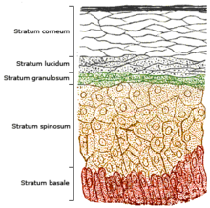

* Absorption:
* Absorbed in Small Intestine for which Bile is required.
* Vitamin D2 and D3 are not biologically active they metabolized and converted into active form Vita D that is Calcitriol .
* Synthesis of Calcitriol

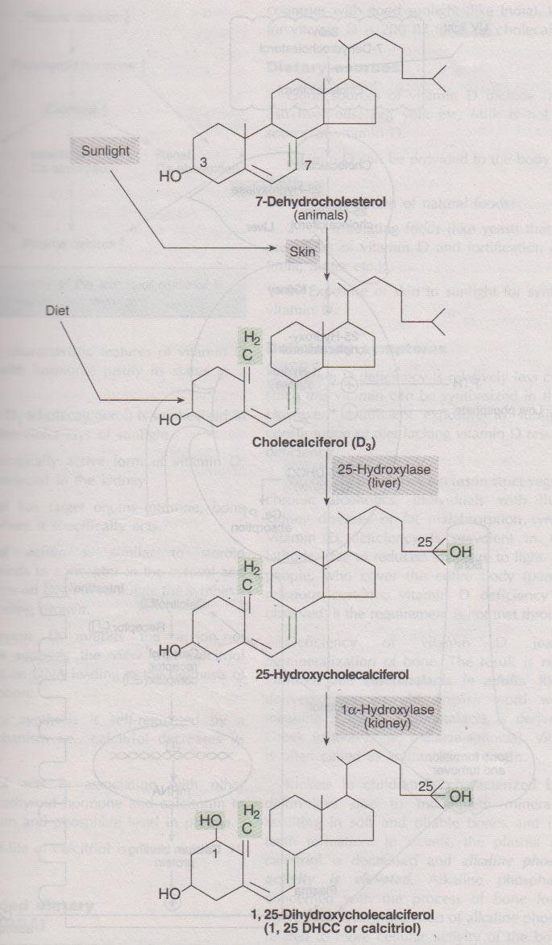

* Role of Vitamin Calcitriol

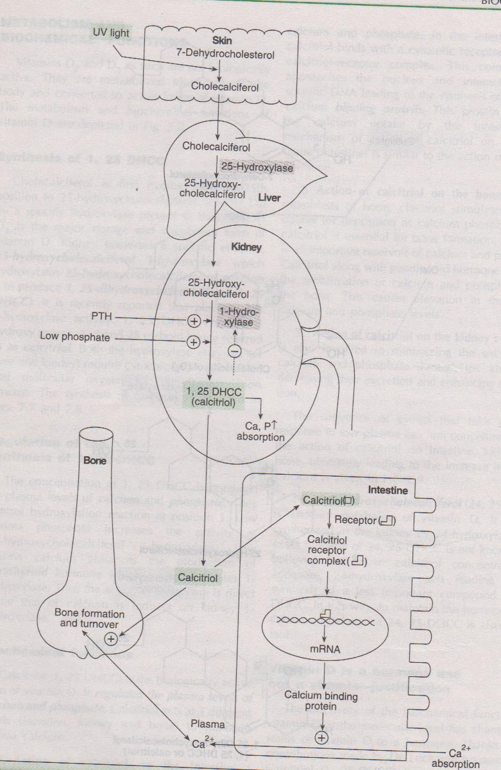

* Daily Requirement:
* 400 IU vitamin D or 10 µg (Microgram) of Cholecalciferol.

Deficiency:

* Hypocalcemia.
* Rickets: ( Children) Demineralization of Bones.
* Weakness in muscles, stop the development of increase in height.
* Osteophoresis: ( Adults)
* Treatment:
* Diet supplement should be with calcium salt. Along with Vitamin D.
* Calcium Salts are Calcium Carbonates, Calcium Gluconate, Calcium Lactate etc.
* Vitamin E (**α-Tocopherol**)
* It is fat soluble vitamin.
* It is naturally occurring Anti-Oxidant.
* It Responsible for normal reproduction in many animals hence it is called as anti-sterility vitamin.
* Evan and bishop in 1922 observed that factor present in the vegetable oil is responsible for rat’s reproduction.
* And named this factor Vitamin E in 1936.
* Isolated compound in this give the name tocopherol because Greek word Tocos – child birth.
* About 8 tocopherols are present in vitamin E but name is given alpha tocopherol because it is more active amongst 8.
* Structure of **α-Tocopherol**:



* **α-Tocopherol**
* (5,7,8-Trimethyl tocol)
* Vitamin E is absorbed in small intestine along with fats. Bile salt is necessary for the absorption of it.
* Functions:
* 1. it prevents non enzymatic oxidation of cell component.
* 2.Essential for the membrane structure and integrity of cell.
* 3. It prevents oxidation of poly unsaturated fatty acids.
* 4. it is responsible for reproduction and prevents sterility.
* 5. it prevents oxidation of Vitamin A
* 6. it required for the absorption of the optimum amino acids from intestine.
* 7. it involve in synthesis of nucleic acids.
* 8. it prevents damage of liver from carbontetrachloride.
* Daily Requirement:
* 10 mg (15 IU) for man.
* 8 mg for woman.
* SOURCE:
* Many vegetable oils are good sources for vitamin E
* Meat,
* Milk.
* Deficiency:
* 1. Sterility.
* 2. Degrative changes in muscles.
* 3. Megaloblastic anaemia.
* 4. Changes in Central Nervous System.

**Vitamin K**

* **Vitamin K** is a group of structurally similar, fat-soluble [vitamins](http://en.wikipedia.org/wiki/Vitamin) that the human body needs for [modification](http://en.wikipedia.org/wiki/Post-translational_modification) of certain proteins required for blood [coagulation](http://en.wikipedia.org/wiki/Coagulation)
* This group of vitamins includes two natural [vitamers](http://en.wikipedia.org/wiki/Vitamer): [vitamin K1](http://en.wikipedia.org/wiki/Phylloquinone) and [vitamin K2](http://en.wikipedia.org/wiki/Vitamin_K2)
* Vitamin K1, also known as **phylloquinone**, **phytomenadione**, or **phytonadione**, is synthesized by plants, and is found in highest amounts in [green leafy vegetables](http://en.wikipedia.org/wiki/Leaf_vegetable) because it is directly involved in photosynthesis. It may be thought of as the "plant form" of vitamin K. It is active in animals and may perform the classic functions of vitamin K in animals, including its activity in the production of blood-clotting proteins. Animals may also convert it to vitamin K2.
* [Vitamin K2](http://en.wikipedia.org/wiki/Vitamin_K2), the main storage form in animals, has several subtypes, which differ in isoprenoid chain length.
* These vitamin K2 homologues are called **menaquinones**, and are characterized by the number of [isoprenoid](http://en.wikipedia.org/wiki/Terpenoid) residues in their side chains. Menaquinones are abbreviated **MK-n**, where **M** stands for menaquinone, the **K** stands for vitamin K, and the **n** represents the number of isoprenoid side chain residues. For example, menaquinone-4 (abbreviated MK-4) has four isoprene residues in its side chain.
* Bacteria in the colon (large intestine) can also convert K1 into vitamin K2. In addition, bacteria typically lengthen the isopreneoid side chain of vitamin K2 to produce a range of vitamin K2 forms
* Vitamin K3 is called Menadione.
* Structure for K1, K2, K3

* Phylloquinone is Present in Plant.
* Menaquinone is produced by intestinal Bacteria.



* Menadione is synthetic form of Vitamin K



* Biochemical Role of Vitamin K :
* It is concern with blood clotting process.
* It involve in conversion of glutamate to gama carboxyglutamate.
* Recommended Dose:
* 70-140 µg/day Adult.
* Source: Cabbage, Cauliflower, Tomatos, Egg yolk, Meat, Liver, Cheese etc.
* Deficiencies:
* Lack of Prothrombin in Blood.
* Hypervitamin K Haemolytic Anaemia, Jaundice.
* **Water Soluble Vitamins:**   
  These are the vitamins which are readily soluble into water and difficult to store in to the body because it rapidly excreted through urine
* **Vitamin C**

**( Ascorbic Acid)**

1.It is water soluble vitamin.

2.Vitamin C plays vital role in human health and dieses.

3.Scurvy has known to man from centuries. A disease related to diet.

4.Vitamin C has antiscorbutic

potential.

5.In 1932 Wagh and King isolated

Vitamin C from lemon juice in crystalline form.

6.Vitamin C is called Ascorbic Acid due to it’s Antiscorbic Properties.

* Synthesis of Vitamin C

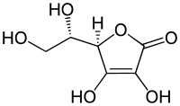

* The vast majority of animals and plants are able to synthesize vitamin C, through a sequence of [enzyme](http://en.wikipedia.org/wiki/Enzyme)-driven steps, which convert [monosaccharides](http://en.wikipedia.org/wiki/Monosaccharides) to vitamin C. In plants, this is accomplished through the conversion of [mannose](http://en.wikipedia.org/wiki/Mannose) or [galactose](http://en.wikipedia.org/wiki/Galactose) to ascorbic acid.
* Ascorbic acid is absorbed in the body by both active transport and simple diffusion.
* **Deficiency**
* [Scurvy](http://en.wikipedia.org/wiki/Scurvy)
* [Scurvy](http://en.wikipedia.org/wiki/Scurvy) is an resulting from lack of vitamin C, since without this vitamin, the synthesised [collagen](http://en.wikipedia.org/wiki/Collagen) is too unstable to perform its function. Scurvy leads to the formation of [brown spots](http://en.wikipedia.org/wiki/Liver_spot) on the skin, spongy gums, and bleeding from all [mucous membranes](http://en.wikipedia.org/wiki/Mucous_membrane). The spots are most abundant on the thighs and legs, and a person with the ailment looks pale, feels depressed, and is partially immobilized. In advanced scurvy there are open, [suppurating wounds](http://en.wikipedia.org/wiki/Suppuration) and loss of [teeth](http://en.wikipedia.org/wiki/Tooth).
* Biological Role:
* **Antioxidant**
* Ascorbic acid is well known for its antioxidant activity, acting as a reducing agent to reverse oxidation in liquids.
* **Immune system**
* Vitamin C is found in high concentrations in immune cells, and is consumed quickly during infections.
* **Antihistamine**
* Vitamin C is a natural [antihistamine](http://en.wikipedia.org/wiki/Antihistamine). It both prevents [histamine](http://en.wikipedia.org/wiki/Histamine) release and increases the detoxification of histamine.
* **Daily requirements**
* The [North American](http://en.wikipedia.org/wiki/North_American) [Dietary Reference Intake](http://en.wikipedia.org/wiki/Dietary_Reference_Intake) recommends 90 milligrams per day and no more than 2 grams (2,000 milligrams) per day.
* **B vitamins:**
* **B vitamins** are a group of water-soluble [vitamins](http://en.wikipedia.org/wiki/Vitamin) that play important roles in [cell](http://en.wikipedia.org/wiki/Cell_(biology)) [metabolism](http://en.wikipedia.org/wiki/Metabolism). The B vitamins were once thought to be a single vitamin, referred to simply as **vitamin B**. Later research showed that they are [chemically](http://en.wikipedia.org/wiki/Chemical) distinct vitamins that often coexist in the same foods. In general, supplements containing all eight are referred to as a **vitamin B complex**.
* **List of B vitamins**
* **Vitamin B1** ([thiamine](http://en.wikipedia.org/wiki/Thiamine))
* **Vitamin B2** ([riboflavin](http://en.wikipedia.org/wiki/Riboflavin))
* **Vitamin B3** ([niacin](http://en.wikipedia.org/wiki/Niacin) or [niacinamide](http://en.wikipedia.org/wiki/Niacinamide))
* **Vitamin B5** ([pantothenic acid](http://en.wikipedia.org/wiki/Pantothenic_acid))
* **Vitamin B6** ([pyridoxine](http://en.wikipedia.org/wiki/Pyridoxine), [pyridoxal](http://en.wikipedia.org/wiki/Pyridoxal), or [pyridoxamine](http://en.wikipedia.org/wiki/Pyridoxamine), or [pyridoxine hydrochloride](http://en.wikipedia.org/wiki/Pyridoxine_hydrochloride))
* **Vitamin B7** ([biotin](http://en.wikipedia.org/wiki/Biotin))(vitamin H)
* **Vitamin B9** ([folic acid](http://en.wikipedia.org/wiki/Folic_acid))
* **Vitamin B12** (various [cobalamins](http://en.wikipedia.org/wiki/Cobalamin); commonly [cyanocobalamin](http://en.wikipedia.org/wiki/Cyanocobalamin) in vitamin supplements)
* **Thiamine (Vitamin B1)**
* Chemistry:
* **Thiamine** or **vitamin B1** named as the "thio-vitamine" ("sulfur-containing vitamin") is a water-soluble [vitamin](http://en.wikipedia.org/wiki/Vitamin) of the [B complex](http://en.wikipedia.org/wiki/B_vitamins).
* It is water soluble vitamin.
* It is anti beriberi vitamin.
* It has specific coenzyme Thiamine pyrophosphate (TPP) which is mostly associated with carbohydrates metabolism.
* In 1936 williams and his associates determines the structure of Thiamine.
* Thiamine contain pyrymidine ring Thiazole ring held by methylene bridge.
* Thiamine is onlynatural compound which having thiazole ring.
* Alcohol group of thiamine esterified with phosphate and form coenzyme TPP.
* Biochemical Functions:
* Pyruvate dehydrogenase catalyses irreversible conversion of pyruvate to acetyl Co A.
* TPP plays vital role in transmission of nerve impulses.
* Recommended Dietary Allowance:
* 1-1.5 mg/day
* Dietary Source:
* Cereals, oil seeds, nuts and yeast are good sources.
* Deficiency:

Beriberi is a neurological and cardiovascular disease.

The three major forms of the disorder are

1.Dry beriberi,

2. Wet beriberi, and

3. Infantile beriberi.

* *Dry beriberi* is characterized principally by peripheral neuropathy consisting of symmetric impairment of sensory, motor, and reflex functions affecting distal more than proximal limb segments and causing calf muscle tenderness.
* *Wet beriberi* is associated with mental confusion, [muscular atrophy](http://en.wikipedia.org/wiki/Muscular_atrophy), [edema](http://en.wikipedia.org/wiki/Edema), [tachycardia](http://en.wikipedia.org/wiki/Tachycardia), [cardiomegaly](http://en.wikipedia.org/wiki/Cardiomegaly), and congestive heart failure in addition to peripheral neuropathy.
* *Infantile beriberi* occurs in infants breast-fed by thiamin-deficient mothers (who may show no sign of thiamine deficiency). Infants may manifest cardiac, aphonic, or pseudomeningitic forms of the disorder. Infants with cardiac beriberi frequently exhibit a loud piercing cry, vomiting, and tachycardia.Convulsions are not uncommon, and death may ensue if thiamine is not administered promptly.
* **Alzheimer's Disease**
* **Riboflavin**

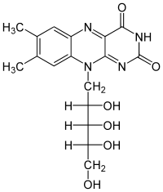

* 7,8-Dimethyl-10-[(2*S*,3*S*,4*R*)-2,3,4,5-tetrahydroxypentyl]benzo[*g*]pteridine-2,4-dione
* The name "riboflavin" comes from "[ribose](http://en.wikipedia.org/wiki/Ribose)" (the sugar whose [reduced](http://en.wikipedia.org/wiki/Reduction_(chemistry)) form, [ribitol](http://en.wikipedia.org/wiki/Ribitol), forms part of its structure) and "[flavin](http://en.wikipedia.org/wiki/Flavin_group)", the ring-moiety which imparts the yellow color to the oxidized molecule (from Latin *flavus*, "yellow"). The reduced form, which occurs in metabolism along with the oxidized form, is colorless.
* **Riboflavin**, also known as **vitamin B2** is an easily absorbed colored [micronutrient](http://en.wikipedia.org/wiki/Micronutrient) with a key role in maintaining [health](http://en.wikipedia.org/wiki/Health) in humans and other animals. It is the central component of the [cofactors](http://en.wikipedia.org/wiki/Cofactor_(biochemistry)) [FAD](http://en.wikipedia.org/wiki/FAD) and [FMN](http://en.wikipedia.org/wiki/Flavin_mononucleotide), and is therefore required by all [flavoproteins](http://en.wikipedia.org/wiki/Flavoprotein). As such, vitamin B2 is required for a wide variety of cellular processes. It plays a key role in energy metabolism, and for the [metabolism](http://en.wikipedia.org/wiki/Metabolism) of [fats](http://en.wikipedia.org/wiki/Fat), [ketone bodies](http://en.wikipedia.org/wiki/Ketone_bodies), [carbohydrates](http://en.wikipedia.org/wiki/Carbohydrate), and [proteins](http://en.wikipedia.org/wiki/Protein).
* vitamin B2 was thought to be the factor necessary for preventing [pellagra](http://en.wikipedia.org/wiki/Pellagra).
* **Biochemical function**
* [Flavin mononucleotide](http://en.wikipedia.org/wiki/Flavin_mononucleotide) (FMN)
* [flavin adenine dinucleotide](http://en.wikipedia.org/wiki/Flavin_adenine_dinucleotide) (FAD)
* Are coenzymes of riboflavin.
* Flavoproteins play important roles in the electron transport chain
* Decarboxylation of pyruvate and [α-ketoglutarate](http://en.wikipedia.org/wiki/%CE%91-ketoglutarate) requires FAD
* Fatty acyl CoA dehydrogenase requires FAD in fatty acid oxidation
* FAD is required to the production of pyridoxic acid from pyridoxal (vitamin B6)
* FAD is required to convert [retinol](http://en.wikipedia.org/wiki/Retinol) ([vitamin A](http://en.wikipedia.org/wiki/Vitamin_A)) to retinoic acid
* Synthesis of an active form of folate (5-methyl THF) is FADH2 dependent
* FAD is required to convert tryptophan to niacin (vitamin B3)
* **Recommended dietary allowance (RDA)**
* for adult men and women are 1.3 mg/day and 1.1 mg/day, respectively
* [Source: Milk](http://en.wikipedia.org/wiki/Milk), [cheese](http://en.wikipedia.org/wiki/Cheese), [leaf vegetables](http://en.wikipedia.org/wiki/Leaf_vegetable), [liver](http://en.wikipedia.org/wiki/Liver_(food)), [kidneys](http://en.wikipedia.org/wiki/Kidney), [legumes](http://en.wikipedia.org/wiki/Legume), [yeast](http://en.wikipedia.org/wiki/Yeast), [mushrooms](http://en.wikipedia.org/wiki/Mushroom), and [almonds](http://en.wikipedia.org/wiki/Almond)[[2]](http://en.wikipedia.org/wiki/Riboflavin) are good sources of vitamin B2.
* **Riboflavin deficiency**
* In humans, signs and symptoms of riboflavin deficiency ([ariboflavinosis](http://en.wikipedia.org/wiki/Ariboflavinosis)) include cracked and red lips, inflammation of the lining of mouth and tongue, mouth ulcers, cracks at the corners of the mouth ([angular cheilitis](http://en.wikipedia.org/wiki/Angular_cheilitis)), and a sore throat. A deficiency may also cause dry and scaling skin, fluid in the mucous membranes, and iron-deficiency anemia. The eyes may also become bloodshot, itchy, watery and sensitive to bright light.

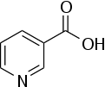

* **Niacin** (also known as **vitamin B3** and **nicotinic acid**)
* Not enough niacin in the diet can cause nausea, skin and mouth lesions, anemia, headaches, and tiredness. Chronic Niacin deficiency leads to a disease called [pellagra](http://en.wikipedia.org/wiki/Pellagra).
* Niacin has been used for over 50 years to increase levels of [HDL](http://en.wikipedia.org/wiki/High-density_lipoprotein) in the blood and has been found to decrease the risk of cardiovascular events modestly in a number of controlled human trials.
* This colorless, water-soluble solid is a derivative of [pyridine](http://en.wikipedia.org/wiki/Pyridine), with a [carboxyl group](http://en.wikipedia.org/wiki/Carboxyl_group) (COOH) at the 3-position.
* It’s Amide form Is called as nicotinamide.
* Nicotinic acid, nicotinamide, and tryptophan (via quinoline acid) are co-factors for nicotinamide adenine dinucleotide (NAD) and nicotinamide adenine dinucleotide phosphate (NADP).

**Dietary needs**

* One recommended daily allowance of niacin is 2–12 mg/day for children, 14 mg/day for women, 16 mg/day for men, and 18 mg/day for pregnant or breast-feeding women.
* **Deficiency**
* A man with pellagra, which is caused by a chronic lack of vitamin B3 in the diet.
* Mild niacin deficiency has been shown to slow metabolism, causing decreased tolerance to cold.
* Severe deficiency of niacin in the diet causes the disease [pellagra](http://en.wikipedia.org/wiki/Pellagra), which is characterized by diarrhea, dermatitis, and dementia, as well as “Casal's necklace” lesions on the lower neck, hyperpigmentation, thickening of the skin, inflammation of the mouth and tongue, digestive disturbances, amnesia, delirium, and eventually death, if left untreated. Common psychiatric symptoms of niacin deficiency include irritability, poor concentration, anxiety, fatigue, restlessness, apathy, and depression.

**Pyridoxine: (Vitamin B6)**

* Vitamin Collectively represent three compound
* Pyridoxine
* Pyridoxal
* Pyridoxamine.
* Isolated in 1939







* Vitamin B6 compounds are pyridine derivatives.
* Different in each other by attachment at 4th carbon atom.
* Pyridoxine –Alcoholic.
* Pyridoxal- Aldehyde.
* Pyridoxamine- Amino.
* Coenzymes- Pyridoxal Phosphte.

Metabolism of amino acids.

* Synthesis of sertonin and Histamine.

Deficiency: Neurological Symptoms, Depression, Convulsion, Peripheral Neuropathy and confusion.

Source: Egg yolk, Fish, Milk, Rice, and Meat.

Daily Requirement: 2-2.2 mg/day.

* Folic acid( Folacin Latin- Leaf )
* It is abundantly found in green vegetables.
* It is important in one carbon metabolism.
* It is used in the treatment of macro cystic Anemia.
* Folic Acid contain three components.
* Active form of folic acid is tetrahydrofolate.
* It is synthesized from folic acid by enzyme dehydrofolate reductase.



**Biochemical Functions:**

* Tetrahydrofolate involved in one carbon metabolism.
* Many important compounds are synthesize in one carbon metabolism.
* Purines,which is incoporated in the DNA and RNA
* Glycine, Serine, Ethanolamine and Choline.
* Daily Requirement:
* 100 Microgram
* Source: Green Vegetables, rains, Yeast, eggs etc.
* Deficiency: Macro cystic anemia. Slow in maturation of erythrocytes.